Report

Laboratory Work 8

Dmitry Ladutsko

July 25, 2022

# 2. Data Warehouse Architecture

## 2.1. Task 01: CREATE Schema of simple Data Warehouse Architecture

|  |  |  |  |
| --- | --- | --- | --- |
| Level Type | Object Name | Tablespace | Description |
| Storage level  SA_* | SA_CUSTOMERS | ts_SA_CUSTOMERS_DATA_01 | Loads data from flat files, stores data about customers. |
| SA_PRODUCTS | ts_SA_PRODUCTS_DATA_01 | Loads data from flat files, stores data about products. |
| DW Cleansing Level | DW_CL | ts_DW_CLEANSING | Loading from stage level |
| DW Level | DW_DATA | ts_DW_DATA_01 | Loading data from cleansing level and preparing it for to the 3 normal form |
| DW Prepare Star Cleansing Level | SAL_DW_CL | ts_SA_DW_CL_01 | Loading data from DW system. Containts views and objects from DW - Level |
| STAR - Cleansing | SAL_CL | ts_SA_CL_001 | Loading data from DW_CL, but clean some redundancy if are some |
| STAR Level | DM_FCT_SALES | ts_SA_FCT_SALES_01 | INFO |
| DM_BORROWERS | ts_SA_BORROWERS_01 |
| DM_CUSTOMERS | ts_SA_DIM_CUSTOMERS_01 |
| DM_PRODUCTS | ts_SA_DIM_PRODUCTS_01 |
| DM_GEO | ts_SA_DIM_GEO_01 |

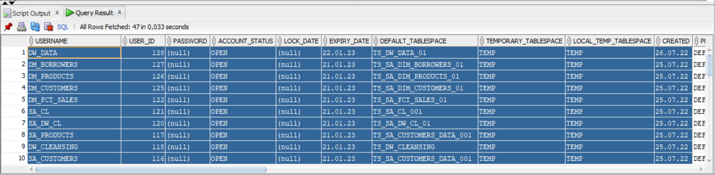

Picture 1 - All created users

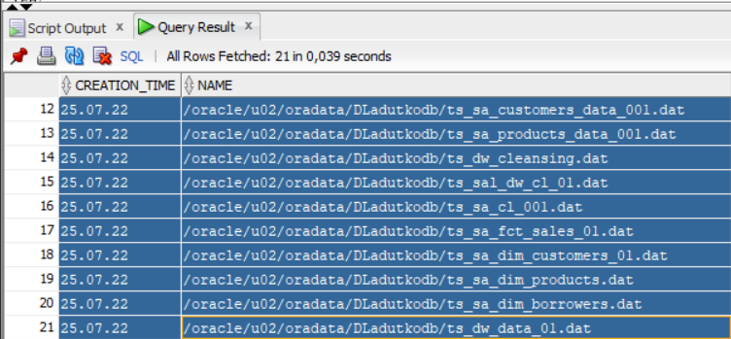

Picture 2 - All created tablespaces

!!!All tasks haven’t been done at this lab will be at business solution task.

All scripts are stored on GitHub!!! (link in README file in Labs folder)

## 3.3. Task 09: Grants Object Privileges

|  |  |
| --- | --- |
| User | Privileges |
| SA_PRODUCTS | grant connect, resource to SA_PRODUCTS |
| SA_CUSTOMERS | grant connect, resource to SA_CUSTOMERS |
| DW_CLEANSING | grant connect, resource, create view to DW_CLEANSING |
| DW_DATA | grant connect, resource to DW_DATA |
| SA_DW_CL | grant connect, resource, create view to SA_DW_CL |
| SA_CL | grant connect, resource, create view to SA_CL |
| DM_FCT_SALES | grant connect, resource, create view to DM_FCT_SALES |
| DM_CUSTOMERS | grant connect, resource, create view to DM_CUSTOMERS |
| DM_PRODUCTS | grant connect, resource, create view to DM_PRODUCTS |
| DM_BORROWERS | grant connect, resource, create view to DM _BORROWERS |